**RECOPE Project**

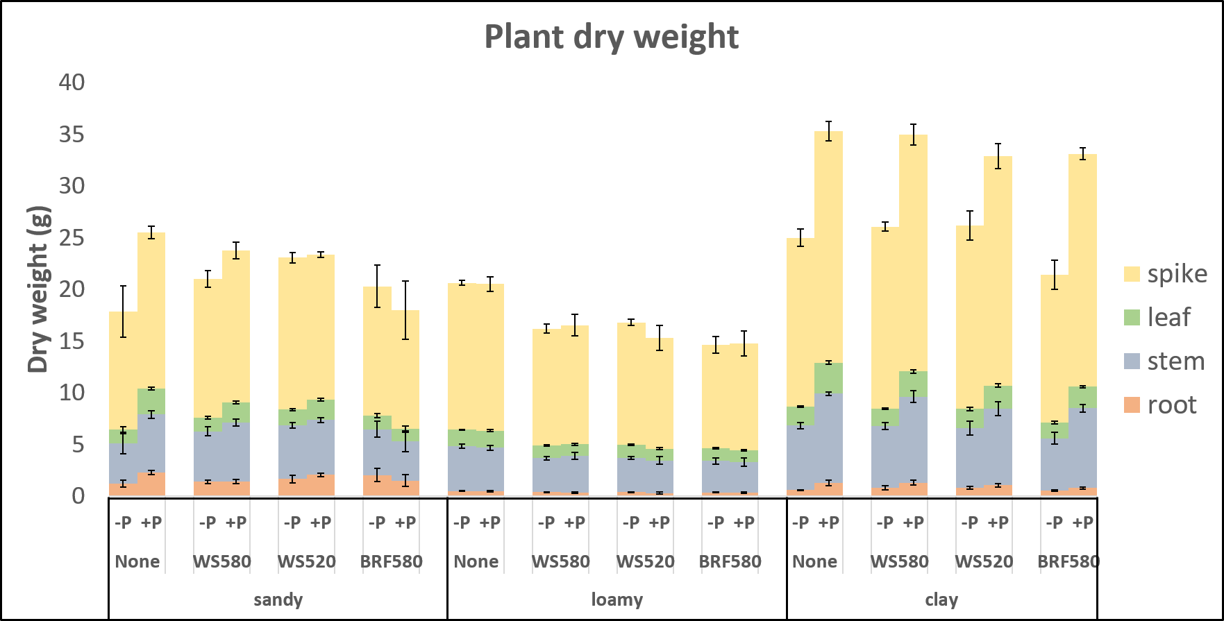**Preliminary Results**

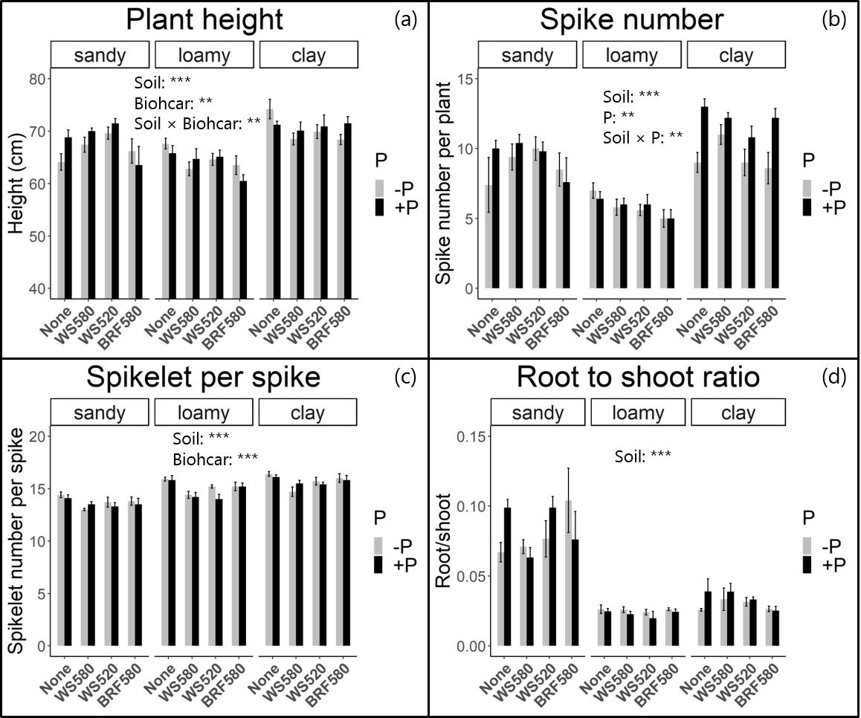**Figure 1.** Plant dry weight of wheat under different soil types and biochar combinations with and without phosphorus (P) application. The data represent mean values ± SE of five replicates. *, ** and *** indicate the significant differences of the total dry weight between soil type, biochar, P and their interaction effects at *P* < 0.05, *P* < 0.01 and *P* < 0.001, respectively.

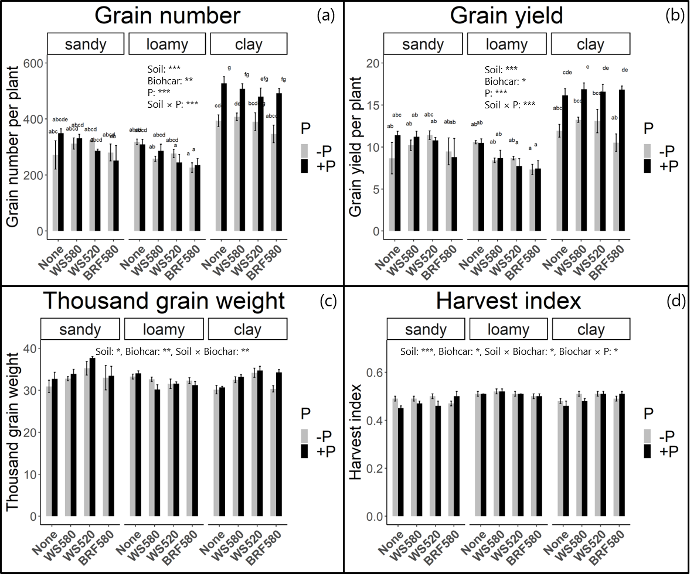**Figure 2.** Shoot height (a), spike number per plant (b), spikelet per spike per plant (c), and root to shoot ratio (d) of wheat plants under different soil types and biochar combinations with and without P application. The data represent mean values ± SE of five replicates. *, ** and *** indicate the significant differences of the total dry weight between soil type, biochar, phosphorus and their interaction effects at *P* < 0.05, *P* < 0.01 and *P* < 0.001, respectively.

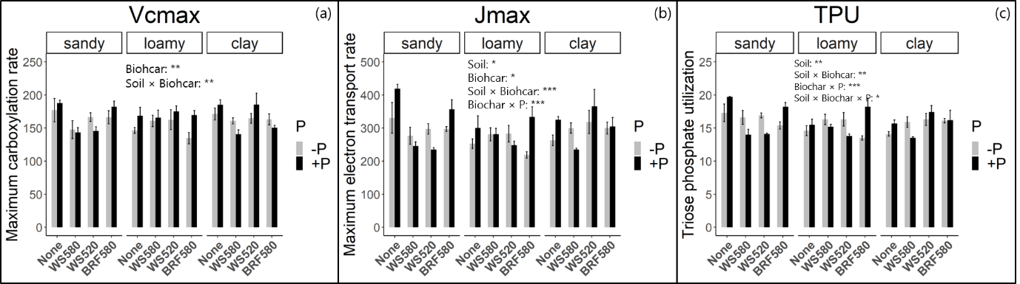**Figure 3.** Grain number (a), grain yield (b), thousand grain weight (c), and harvest index (d) of wheat plants under different soil types and biochar combinations with and without P application. The data represent mean values ± SE of five replicates. *, ** and *** indicate the significant differences of the total dry weight between soil type, biochar, phosphorus and their interaction effects at *P* < 0.05, *P* < 0.01 and *P* < 0.001, respectively.

**Figure 4.** Maximum carboxylation rate (*V*cmax) (a), maximum electron transport rate (*J*max) (b), and triose phosphate utilization (*TPU*) (c) of wheat plants under different soil types and biochar combinations with and without P application. The data represent mean values ± SE of five replicates. *, ** and *** indicate the significant differences of the total dry weight between soil type, biochar, phosphorus and their interaction effects at *P* < 0.05, *P* < 0.01 and 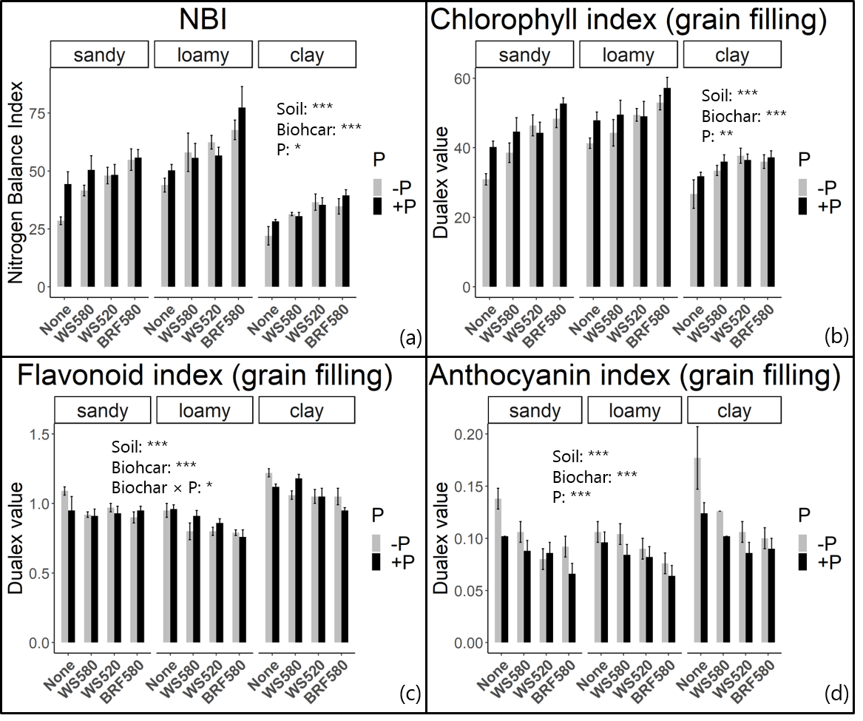*P* < 0.001, respectively.

**Figure 5.** Nitrogen balance index (a), chlorophyll index (b), flavonoid index (c), and anthocyanin index (d) of wheat plants under different soil types and biochar combinations with and without P application. The data represent mean values ± SE of five replicates. *, ** and *** indicate the significant differences of the total dry weight between soil type, biochar, phosphorus and their interaction effects at *P* < 0.05, *P* < 0.01 and *P* < 0.001, respectively.

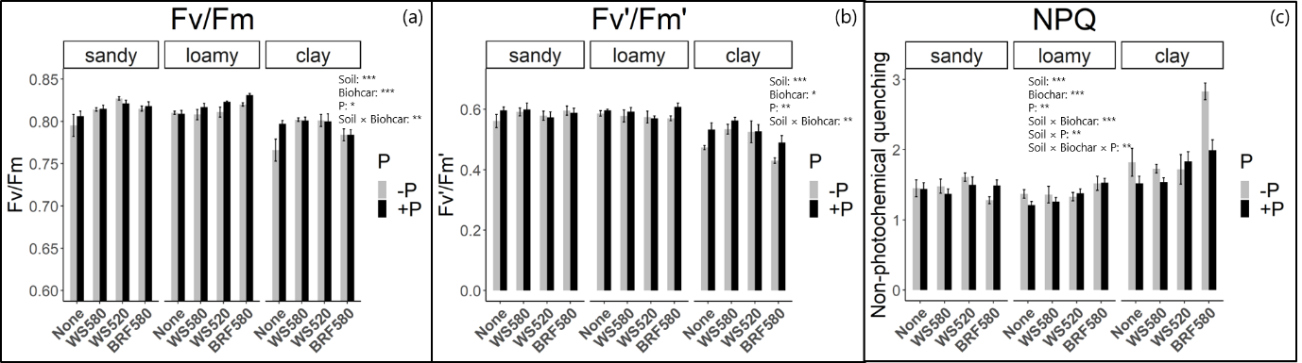

**Figure 6.** Maximum quantum efficiency of photosystem II in darkness (Fv/Fm) (*V*cmax) (a) and in the light (Fv’/Fm’) (b), and non-photochemical quenching (NPQ) (c) of wheat plants under different soil types and biochar combinations with and without P application. The data represent mean values ± SE of five replicates. *, ** and *** indicate the significant differences of the total dry weight between soil type, biochar, phosphorus and their interaction effects at *P* < 0.05, *P* < 0.01 and *P* < 0.001, respectively.